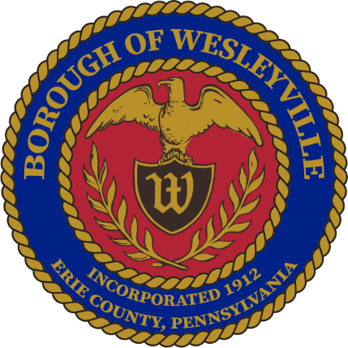

**January 2025 Council Meeting**

**Wesleyville Borough, Erie County, Pennsylvania**

*\*\*Draft Agenda\*\**

**Public Meeting Information**

January 22nd, 2025, at 6:00PM

In-Person – Borough Hall located at 3421 Buffalo Road, Erie, PA 16510.

Live Virtual Option - *Coming Soon*

Archive of Recordings - *Coming Soon*

1. **Call to Order –** By: Mrs. Julius, President
2. **Invocation -** By: Mrs. Julius, President
3. **Pledge of Allegiance -** By: Mrs. Julius, President
4. **Roll Call:** (Present) (Not Present)
   1. Mayor, E Paul Johnson;
   2. Council President, Regina Julius;
   3. Council Vice President, Fred Petrini;
   4. Council President Pro Tem, Paul Bills
   5. Councilperson, Steve Alfieri;
   6. Councilperson, Jake Wilder;
   7. Councilperson, Sandy Morrow;
   8. Councilperson, Cassandra Kolesar;
   9. Tax Collector, Lisa Huff;
   10. Solicitor, Ed Betza;
   11. Engineer, Mark Corey;
   12. Police Chief, Robert Buzanowski;
   13. Borough Manager/Secretary, Marcus Jacobs;
   14. Public Works Supervisor, Joseph Ball
5. **Citizens to address Council:**
6. **Approve Agenda:** 
   1. A motion to approve of the agenda for tonight’s meeting, January 22nd, 2025.
7. **Approve Minutes:**
   1. A motion to approve the minutes from the January 8th, 2025 Council Meeting.
8. **Top of Agenda – Reserved Time:**
9. **Borough Administration:**
   1. Borough Manager – Manager Jacobs
      1. In your packet is an Ethics statement that is required to be filled out. Please do so and return them to me ASAP.
   2. Police Department – Chief Buzanowski
   3. Fire Department – Board member, Jeffrey Simpson
   4. Treasurer’s Report *(Council Meetings Only) -* Manager Jacobs
   5. Engineer’s Report *(Council Meetings Only)*
   6. Solicitor’s Report *(Council Meetings Only)*
10. **Executive Session:** None Anticipated
    1. Recessed:
       1. Borough Council recessed public session at for an executive session regarding...
    2. Reconvened:
       1. Borough Council reconvened the public session at .
    3. Motions resulting from the Executive Session:
11. **Old Business:**
    1. Discussion – Ordinance to increase the Tax Collector’s wages, would be effective January 2026 when the newly elected Tax Collector is sworn in.
       1. Current Salary - $7,542
       2. Potential percentages - (**5%** - $377.10, **10%** - $754.20, **15%** - $1,131.30, **20%** - $1,508.40)
12. **New Business:** 
    1. Motion to approve of signing the official acknowledgement to Donny McKee for surpassing 30 years of service to the Borough and to approve of purchasing a plaque to be hung in the Borough Hall.
    2. Motion to approve of extending an offer of employment to Zac Clayton for the position of Police Officer in the Wesleyville Police Department on condition of receiving a passing score on the written exam and passing the background check.
    3. Motion to adopt Resolution 2025-002 – A resolution making application to Erie County for the Borough’s annual allotment of County Liquid Fuels.
       1. Budgeted in to be used for street lighting, as has been done historically.
    4. Motion to sign all the Thank You cards for the donors.
13. **Borough Boards & Commissions**
    1. Planning Commission – Manager Jacobs
       1. Next meeting is on February 19th at 5pm at the Borough Hall.
    2. Safety Committee – Mrs. Morrow
       1. Next meeting is on February 19th at 1pm at the Borough Hall.
14. **Council - Committee Reports:** 
    1. Public Works/Streets - Mr. Bills
    2. Sanitary and Storm Sewers - Mr. Wilder
    3. Public Safety - Mr. Alfieri
    4. Refuse and Recycling - Mrs. Kolesar
    5. Community Engagement - Mrs. Morrow
15. **Council – Members:**
    1. Councilmember – Mr. Alfieri
    2. Councilmember - Mr. Bills
    3. Councilmember – Mrs. Kolesar
    4. Councilmember – Mrs. Morrow
    5. Councilmember – Mr. Wilder
16. **Council - Officers:**
    1. Mayor – Mr. Johnson
    2. Council Vice President - Mr. Petrini
    3. Council President - Mrs. Julius
17. **Good of the Order:**
    1. Next Council Meeting is on February 12th, 2025, 6PM in the Borough Hall.
    2. Next Work Session is on February 26th, 2025, 6PM in the Borough Hall.
18. **Meeting Adjournment:**
    1. A motion to adjourn the meeting made by___, seconded by ___, passed _____. Adjourned at

Respectfully submitted to the public record of the Borough of Wesleyville after the meeting minutes were approved by the Borough Council at the public Council Meeting on the ______ day of ______________, _________.

_____________________________________

Marcus A Jacobs, Borough Manager/Secretary Official Raised Seal of the Borough of Wesleyville