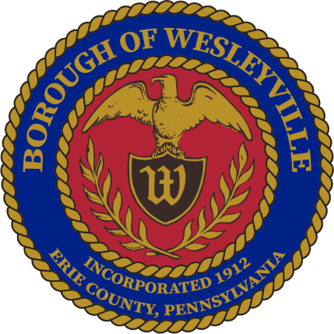

**February 2025 Council Meeting**

**Wesleyville Borough, Erie County, Pennsylvania**

*\*\*Draft Agenda\*\**

**Public Meeting Information**

February 12th, 2025, at 6:00PM

In-Person – Borough Hall located at 3421 Buffalo Road, Erie, PA 16510.

Live Virtual Option - *Coming Soon*

Archive of Recordings - *Coming Soon*

1. **Call to Order –** By: Mrs. Julius, President
2. **Invocation -** By: Mrs. Julius, President
3. **Pledge of Allegiance -** By: Mrs. Julius, President
4. **Roll Call:** (Present) (Not Present)
   1. Mayor, E Paul Johnson;
   2. Council President, Regina Julius;
   3. Council Vice President, Fred Petrini;
   4. Council President Pro Tem, Paul Bills
   5. Councilperson, Steve Alfieri;
   6. Councilperson, Jake Wilder;
   7. Councilperson, Sandy Morrow;
   8. Councilperson, Cassandra Kolesar;
   9. Tax Collector, Lisa Huff;
   10. Solicitor, Ed Betza;
   11. Engineer, Mark Corey;
   12. Police Chief, Robert Buzanowski;
   13. Borough Manager/Secretary, Marcus Jacobs;
   14. Public Works Supervisor, Joseph Ball
5. **Citizens to address Council:**
6. **Approve Agenda:** 
   1. A motion to approve of the agenda for tonight’s meeting, February 12th, 2025.
7. **Approve Minutes:**
   1. A motion to approve the minutes from the January 22nd, 2025 Council Meeting.
8. **Top of Agenda – Reserved Time:**
9. **Borough Administration:**
   1. Borough Manager – Manager Jacobs
      1. In your packet is an Ethics statement that is required to be filled out. Please do so and return them to me ASAP.
   2. Police Department – Chief Buzanowski
   3. Fire Department – Board member, Jeffrey Simpson
   4. Treasurer’s Report *(Council Meetings Only) -* Manager Jacobs
      1. Get treasurer’s reports
   5. Engineer’s Report *(Council Meetings Only)*
   6. Solicitor’s Report *(Council Meetings Only)*
10. **Executive Session:** Anticipated
    1. Recessed:
       1. Borough Council recessed public session at for an executive session regarding personnel contract matters.
    2. Reconvened:
       1. Borough Council reconvened the public session at .
    3. Motions resulting from the Executive Session:
11. **Old Business:**
    1. Tabled until further research is completed – Ordinance to increase the Tax Collector’s wages, would be effective January 2026 when the newly elected Tax Collector is sworn in.
       1. Current Salary - $7,542
       2. Potential percentages - (**5%** - $377.10, **10%** - $754.20, **15%** - $1,131.30, **20%** - $1,508.40)
12. **New Business:** 
    1. Motion to approve of the sale of the 2012 Chevy Tahoe and the 2015 Ford Explorer at the Erie County auto auction.
       1. *New PD cruisers delivered and in service, these old ones can now be sold.*
       2. *Should we keep the 2012 Tahoe and potentially provide that to the Fire Dept for a quick response vehicle?*
    2. Motion to approve of the proposal from ____ to complete the Borough’s 2024 annual audit.
       1. *Our auditor in January informed me that due to staffing shortages they would be unable to complete the audit this year.*
       2. *Reached out to about 8 firms, several declined outright. 3 proposals total.*
    3. Motion to approve of extending an offer of employment to Carlos Cruz-Cooney for the position of Police Officer in the Wesleyville Police Department on condition of passing the background check.
    4. Motion to approve of transferring several computers and monitors to the Wesleyville Hose Company.
       1. *We are upgrading all of ours due to a grant so we will not be needing these additional PCs.*
    5. Motion to approve the signing of the written approval for Manager Jacobs’ anticipated Erie County Council run.
    6. Discussion - Dumpster Ordinance. Review the one pager drafted up by the Planning Commission
13. **Borough Boards & Commissions**
    1. Planning Commission – Manager Jacobs
       1. Next meeting is on February 19th at 5pm at the Borough Hall.
    2. Safety Committee – Mrs. Morrow
       1. Next meeting is on February 19th at 1pm at the Borough Hall.
14. **Council - Committee Reports:** 
    1. Public Works/Streets - Mr. Petrini
    2. Sanitary and Storm Sewers - Mr. Wilder
    3. Public Safety - Mr. Alfieri
    4. Refuse and Recycling - Mrs. Kolesar
    5. Community Engagement - Mrs. Morrow
       1. *2025 WCD Budget*
15. **Council – Members:**
    1. Councilmember – Mr. Alfieri
    2. Councilmember - Mr. Bills
    3. Councilmember – Mrs. Kolesar
    4. Councilmember – Mrs. Morrow
    5. Councilmember – Mr. Wilder
16. **Council - Officers:**
    1. Mayor – Mr. Johnson
    2. Council Vice President - Mr. Petrini
    3. Council President - Mrs. Julius
17. **Good of the Order:**
    1. Next Work Session is on February 26th, 2025, 6PM in the Borough Hall.
    2. Next Council Meeting is on March 12th, 2025, 6PM in the Borough Hall.
18. **Meeting Adjournment:**
    1. A motion to adjourn the meeting made by___, seconded by ___, passed _____. Adjourned at

Respectfully submitted to the public record of the Borough of Wesleyville after the meeting minutes were approved by the Borough Council at the public Council Meeting on the ______ day of ______________, _________.

_____________________________________

Marcus A Jacobs, Borough Manager/Secretary Official Raised Seal of the Borough of Wesleyville