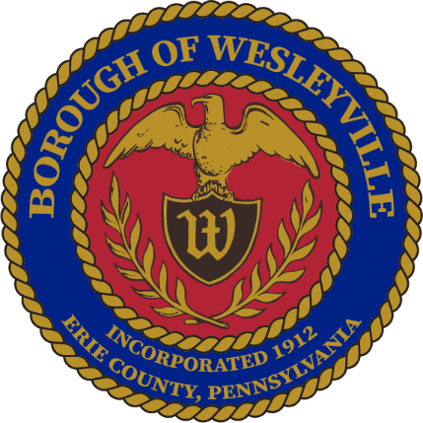

**February 2025 Council Meeting**

**Wesleyville Borough, Erie County, Pennsylvania**

*\*\*Draft Agenda\*\**

**Public Meeting Information**

February 26th, 2025, at 6:00PM

In-Person – Borough Hall located at 3421 Buffalo Road, Erie, PA 16510.

Live Virtual Option - *Coming Soon*

Archive of Recordings - *Coming Soon*

1. **Call to Order –** By: Mrs. Julius, President
2. **Invocation -** By: Mrs. Julius, President
3. **Pledge of Allegiance -** By: Mrs. Julius, President
4. **Roll Call:** (Present) (Not Present)
   1. Mayor, E Paul Johnson;
   2. Council President, Regina Julius;
   3. Council Vice President, Fred Petrini;
   4. Council President Pro Tem, Paul Bills
   5. Councilperson, Steve Alfieri;
   6. Councilperson, Jake Wilder;
   7. Councilperson, Sandy Morrow;
   8. Councilperson, Cassandra Kolesar;
   9. Tax Collector, Lisa Huff;
   10. Solicitor, Ed Betza;
   11. Engineer, Mark Corey;
   12. Police Chief, Robert Buzanowski;
   13. Borough Manager/Secretary, Marcus Jacobs;
   14. Public Works Supervisor, Joseph Ball
5. **Citizens to address Council:**
6. **Approve Agenda:** 
   1. A motion to approve of the agenda for tonight’s meeting, February 26th, 2025.
7. **Approve Minutes:**
   1. A motion to approve the minutes from the February 12th, 2025 Council Meeting.
8. **Top of Agenda – Reserved Time:**
9. **Borough Administration:**
   1. Borough Manager – Manager Jacobs
      1. Ethics Packet -
      2. Manager’s Report
      3. Preliminary 2025 Seal Coating/Resurfacing Plans
   2. Police Department – Chief Buzanowski
   3. Fire Department – Board member, Jeffrey Simpson
   4. Treasurer’s Report *(Council Meetings Only) -* Manager Jacobs
      1. A motion to acknowledge receipt of the January 2025 Depository Log and the Transfer Log
      2. A motion to acknowledge receipt of the January 2025 Profit & Loss Reports for the General, Sewer, Garbage, and Liquid Fuels funds
      3. A motion to acknowledge receipt of the January 2025 Check Details from the General, Sewer, and Garbage funds
   5. Engineer’s Report *(Council Meetings Only)*
   6. Solicitor’s Report *(Council Meetings Only)*
10. **Executive Session:** Anticipated
    1. Recessed:
       1. Borough Council recessed public session at for an executive session regarding personnel contract matters.
    2. Reconvened:
       1. Borough Council reconvened the public session at .
    3. Motions resulting from the Executive Session:
11. **Old Business:**
    1. **Tabled** until further research is completed – Ordinance to increase the Tax Collector’s wages, would be effective January 2026 when the newly elected Tax Collector is sworn in.
       1. Current Salary - $7,542
       2. Potential percentages - (**5%** - $377.10, **10%** - $754.20, **15%** - $1,131.30, **20%** - $1,508.40)
12. **New Business:** 
    1. Motion to approve of the amendment to the Wesleyville Police Contract according to the letter written by the Wesleyville Police Association.
       1. *Remove the lowest class level, Class E, from the contract.*
       2. *Bump up two officers, a class D and a Class C by one class level to reflect the change to the Class structure.*
       3. *Review the tables with the approved budget and the suggested changes.*
13. **Borough Boards & Commissions**
    1. Planning Commission – Manager Jacobs
       1. Next meeting is on March 19th at 5pm at the Borough Hall.
    2. Safety Committee – Mrs. Morrow
       1. Next meeting is on March 19th at 1pm at the Borough Hall.
14. **Council - Committee Reports:** 
    1. Public Works/Streets - Mr. Petrini
    2. Sanitary and Storm Sewers - Mr. Wilder
    3. Public Safety - Mr. Alfieri
    4. Refuse and Recycling - Mrs. Kolesar
    5. Community Engagement - Mrs. Morrow
15. **Council – Members:**
    1. Councilmember – Mr. Alfieri
    2. Councilmember - Mr. Bills
    3. Councilmember – Mrs. Kolesar
    4. Councilmember – Mrs. Morrow
    5. Councilmember – Mr. Wilder
16. **Council - Officers:**
    1. Mayor – Mr. Johnson
    2. Council Vice President - Mr. Petrini
    3. Council President - Mrs. Julius
17. **Good of the Order:**
    1. Next Council Meeting is on March 12th, 2025, 6PM in the Borough Hall.
    2. Next Work Session is on March 26th, 2025, 6PM in the Borough Hall.
18. **Meeting Adjournment:**
    1. A motion to adjourn the meeting made by___, seconded by ___, passed _____. Adjourned at

Respectfully submitted to the public record of the Borough of Wesleyville after the meeting minutes were approved by the Borough Council at the public Council Meeting on the ______ day of ______________, _________.

_____________________________________

Marcus A Jacobs, Borough Manager/Secretary Official Raised Seal of the Borough of Wesleyville