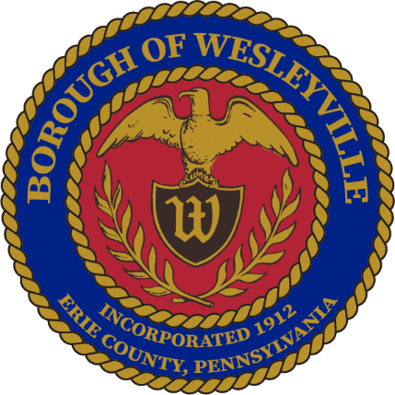

**MAY 2025 Work Session Meeting**

**Wesleyville Borough, Erie County, Pennsylvania**

*\*\*Draft Agenda\*\**

**Public Meeting Information**

May 28th, 2025, at 6:00PM

In-Person – Borough Hall located at 3421 Buffalo Road, Erie, PA 16510.

Live Virtual Option - *Coming Soon*

Archive of Recordings - *Coming Soon*

1. **Call to Order –** By: Mrs. Julius, President
2. **Invocation -** By: Mrs. Julius, President
3. **Pledge of Allegiance -** By: Mrs. Julius, President
4. **Roll Call:** (Present) (Not Present)
   1. Mayor, E Paul Johnson;
   2. Council President, Regina Julius;
   3. Council Vice President, Fred Petrini;
   4. Council President Pro Tem, Paul Bills
   5. Councilperson, Steve Alfieri;
   6. Councilperson, Jake Wilder;
   7. Councilperson, Sandy Morrow;
   8. Councilperson, Cassandra Kolesar;
   9. Tax Collector, Lisa Huff;
   10. Solicitor, Ed Betza;
   11. Engineer, Mark Corey;
   12. Police Chief, Robert Buzanowski;
   13. Borough Manager/Secretary, Marcus Jacobs;
   14. Public Works Supervisor, Joseph Ball
5. **Citizens to address Council:**
6. **Approve Agenda:** 
   1. A motion to approve of the agenda for tonight’s meeting, May 24th , 2025.
7. **Approve Minutes:**
   1. A motion to approve the minutes from the May 14th, 2025 Council Meeting.
8. **Top of Agenda – Reserved Time:**
9. **Borough Administration:**
   1. Borough Manager – Manager Jacobs
   2. Police Department – Chief Buzanowski
      1. Police Cruiser Update – Insurance payments received, getting Lease Terms ironed out.
   3. Fire Department – Board member, Jeffrey Simpson
      1. Postponed Public Townhall
   4. Treasurer’s Report *(Council Meetings Only) -* Manager Jacobs
   5. Treasurer’s Report *(Council Meetings Only) -* Manager Jacobs
   6. Engineer’s Report *(Council Meetings Only)*
   7. Solicitor’s Report *(Council Meetings Only)*
10. **Executive Session:** None Anticipated
    1. Recessed:
       1. Borough Council recessed public session at for an executive session regarding ongoing legal/contractual matters.
    2. Reconvened:
       1. Borough Council reconvened the public session at .
    3. Motions resulting from the Executive Session: None Anticipated
11. **Old Business:**
    1. **Tabled** until further research is completed – Ordinance to increase the Tax Collector’s wages, would be effective January 2026 when the newly elected Tax Collector is sworn in.
       1. Current Salary - $7,542
       2. Potential percentages - (**5%** - $377.10, **10%** - $754.20, **15%** - $1,131.30, **20%** - $1,508.40)
12. **New Business:** 
    1. Motion to adopt Ordinance 2025-008 - Adjusting Parking Regulation along a block of Edison Avenue.
       1. Advertised May 18, 2025, ready for passage.
    2. Motion to approve a quote from ETG Communications for the installation of cameras in Hinkler Park near the bathrooms for a total of $3,587.28.
    3. Motion to approve Resolution 2025-009 for the submission of a grant for the Wesleyville Fire Station Modernization Project to the Pennsylvania Fire Commissioner’s Municipal Fire Department Capital Grant Program in the amount of $100,000.
    4. Motion to approve Resolution 2025-010 for the submission of a grant for the Regional Training Center Establishment Project to the Pennsylvania Fire Commissioner’s Municipal Fire Department Capital Grant Program in the amount of $100,000.
    5. Motion to approve entering a lease with ____ for the acquisition of a 2023 Ford Interceptor for ____ per year for __ months through ___ 20__.
       1. We decided to go this route instead of a loan because it takes less approvals.
13. **Borough Boards & Commissions**
    1. Planning Commission – Manager Jacobs
       1. Next meeting is on June 18th at 5pm at the Borough Hall.
    2. Safety Committee – Mrs. Morrow
       1. Next meeting is on June 18th at 1pm at the Borough Hall.
14. **Council - Committee Reports:** 
    1. Public Works/Streets - Mr. Petrini
    2. Sanitary and Storm Sewers - Mr. Wilder
    3. Public Safety - Mr. Alfieri
    4. Refuse and Recycling - Mrs. Kolesar
    5. Community Engagement - Mrs. Morrow
       1. Borough Charm Award – Window opening soon, spread the word and get people to submit addresses.
15. **Council – Members:**
    1. Councilmember – Mr. Alfieri
    2. Councilmember - Mr. Bills
    3. Councilmember – Mrs. Kolesar
    4. Councilmember – Mrs. Morrow
    5. Councilmember – Mr. Wilder
16. **Council - Officers:**
    1. Mayor – Mr. Johnson
       1. Discussion about a Borough Fundraiser Luncheon.
    2. Council Vice President - Mr. Petrini
    3. Council President - Mrs. Julius
17. **Good of the Order:**
    1. Next Council Meeting is on June 11th, 2025, 6PM in the Borough Hall
    2. Next Work Session is on June 25th, 2025, 6PM in the Borough Hall.
    3. Joint Municipal Meeting – July 7th at 6pm in Lawrence Park
18. **Meeting Adjournment:**
    1. A motion to adjourn the meeting made by___, seconded by ___, passed _____. Adjourned at

Respectfully submitted to the public record of the Borough of Wesleyville after the meeting minutes were approved by the Borough Council at the public Council Meeting on the ______ day of ______________, _________.

_____________________________________

Marcus A Jacobs, Borough Manager/Secretary Official Raised Seal of the Borough of Wesleyville