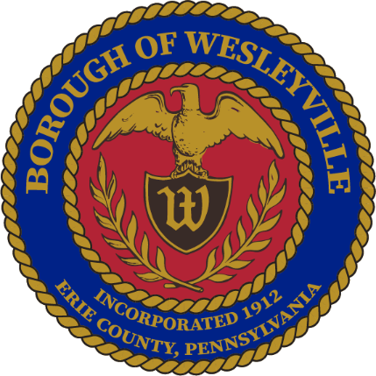
October 2025 Work Session Meeting
Wesleyville Borough, Erie County, Pennsylvania
**Draft Agenda**

Public Meeting Information
October 22nd, 2025, at 6:00PM
In-Person – Borough Hall located at 3421 Buffalo Road, Erie, PA 16510.
Live Virtual Option – Link available at Wesleyville.gov/Council
Archive of Recordings – Videos at Wesleyville.gov/Council

- Call to Order – By: Mrs. Julius, President
- Invocation - By: Mrs. Julius, President
- Pledge of Allegiance - By: Mrs. Julius, President
- Roll Call: (Present) (Not Present)
  - Mayor, E Paul Johnson;
  - Council President, Regina Julius;
  - Council Vice President, Fred Petrini;
  - Council President Pro Tem, Paul Bills;
  - Councilperson, Steve Alfieri;
  - Councilperson, Jake Wilder;
  - Councilperson, Sandy Morrow;
  - Councilperson, Cassandra Kolesar;
  - Tax Collector, Lisa Huff;
  - Solicitor, Ed Betza;
  - Engineer, Mark Corey;
  - Police Chief, Robert Buzanowski;
  - Borough Manager/Secretary, Marcus Jacobs;
  - Public Works Supervisor, Joseph Ball;
  - Borough Clerk, Heidi Savage
- Citizens to address Council:
- Approve Agenda:
  - Motion to approve of the agenda for tonight’s meeting, October 22nd, 2025.
- Approve Minutes:
  - Motion to approve the minutes from the October 8th, 2025 Council Meeting.
- Top of Agenda – Reserved Time:
- Borough Administration:
  - Borough Manager – Manager Jacobs
    - Council Bios for Website – Fill out the worksheet provided and photo can be taken tonight if requested.
    - Monthly Stipend for Redundant Insurance Coverage – Read through the written policy approved at last meeting.
  - Police Department – Chief Buzanowski
    - Police Regionalization Update
      - Next meeting 12/11/25 at 5:30pm at the Borough Hall.
  - Fire Department – Chief Wiercinski
  - Treasurer’s Report (Council Meetings Only) - Manager Jacobs
  - Engineer’s Report (Council Meetings Only)
  - Solicitor’s Report (Council Meetings Only)
- Old Business:
  - (Tabled) Motion to authorize the advertisement and public display of Ordinance 2025-017, amending the Borough’s solid waste ordinance.
    - Revised the allowable weekly collection limit to two approved containers OR up to four approved bags per household. Or 1 bin and no more than 2 bags.
    - Bins must have a lid that can shut, not a mountain of bags.
  - (Tabled) Motion to approve of the Health Insurance Renewals for the UPMC Hospitalization, VBA Vision, and TruAssure Dental premiums
    - Dental and Vision held their rates constant.
    - Hospitalization premiums are determined based on the participant’s age. UPMC increased year over year for the same age by 7.8%.
    - Considering everyone gets one year only, for us a total of about 11% increase.
- New Business:
  - Motion to adopt Resolution 2025-030 – Resolution to Exonerate Certain parcels as requested by the Erie County Tax Claim Bureau according to the list they provided and attached to the resolution.
    - Approved to exonerate at the last meeting, however Manager Jacobs was unaware it needed a resolution.
  - Motion to approve of a new office copier lease with Ford Office Technologies for an updated model copier for a 60-month term.
    - The same price as the current agreement in place, which was signed in November 2020.
    - Terms - $126.45 per month for lease. $0.0088 per page printed. No maintenance, ink, or service expense to the Borough.
- Borough Boards & Commissions
  - Planning Commission – Manager Jacobs
    - Next meeting is on November 19th. 2025 at 5pm at the Borough Hall.
  - Safety Committee – Mrs. Morrow
    - Next meeting is on November 19th, 2025 at 1pm at the Borough Hall
- Council - Committee Reports:
  - Public Works/Streets - Mr. Petrini
  - Sanitary and Storm Sewers - Mr. Wilder
  - Public Safety - Mr. Alfieri
  - Refuse and Recycling - Mrs. Kolesar
  - Community Engagement - Mrs. Morrow
    - Wesleyville Community Day – Fundraiser - Pancake Breakfast on November 2nd at 11:30am
- Council – Members:
  - Councilmember – Mr. Alfieri
  - Councilmember - Mr. Bills
  - Councilmember – Mrs. Kolesar
  - Councilmember – Mrs. Morrow
  - Councilmember – Mr. Wilder
- Council - Officers:
  - Mayor – Mr. Johnson
  - Council Vice President - Mr. Petrini
  - Council President - Mrs. Julius
- Executive Session: Anticipated
  - Recessed:
    - Borough Council recessed public session at _________for an executive session regarding Police Contract negotiations.
  - Reconvened:
    - Borough Council reconvened the public session at __________
  - Motions resulting from the Executive Session:
- Good of the Order:
  - Next Council Meeting is on November 12th, 2025, 6PM in the Borough Hall
  - Next Work Session Meeting is on November 26th, 2025, 6PM in the Borough Hall
  - Joint Municipal Meeting – Proposed Arrangement would be 2nd Monday of 2nd month of each quarter - February 9, 2026, May 11, 2026, August 10, 2026, November 9, 2026
- Meeting Adjournment:
  - A motion to adjourn the meeting made __________ seconded by _________ Adjourned at __________

Respectfully submitted to the public record of the Borough of Wesleyville after the meeting minutes were approved by the Borough Council at the public Council Meeting on the ______ day of ______________, _________.

_____________________________________
Marcus A Jacobs, Borough Manager/Secretary Official Raised Seal of the Borough of Wesleyville

