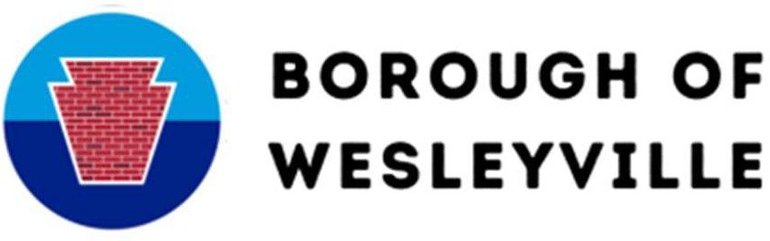

SEWER LATERAL APPLICATION

# Application Date:

|  |  |
| --- | --- |
| **OFFICE USE ONLY** | |
| Parcel ID |  |
| Classification |  |
| Permit # |  |

**Fees:** $200.00 – full inspection (camera & certification)

$100.00 – partial inspection (certification)

Inspection Address Property Owner’s Name Tenant Name Property Owner’s Address Property Owner’s Phone

# PLEASE READ AND SIGN

I, the undersigned, do hereby affirm the statements are true and correct and the information on this application may be relied upon by the Borough in considering the permit. Any false statements made knowingly shall be grounds for revocation of this permit and may be grounds for criminal action. The inspection fee is due when the application is submitted.

Signature Print Name

OFFICE USE ONLY

Application Approved Y N Date Borough Signature

Comments

ESTIMATED SCHEDULING TIME IS APPROXIMATELY TWO/THREE WEEKS, DEPENDING ON CONTRACTOR AVAILABILITY.

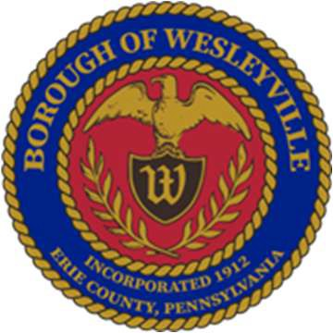**Borough Hall** 3421 Buffalo Road, Erie, PA, 16510-1813

**Website** Wesleyville.gov

**Email** [Admin@wesleyville.gov](mailto:Admin@wesleyville.gov)

**Phone** (814) 899-9124

**Fax** (814) 898-0026

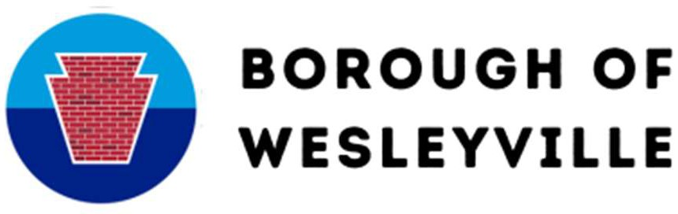

Per Ordinance, prior to listing any property for sale within the Borough of Wesleyville, the complete sewer system must be inspected and pass said inspection. The fee for the inspection is due when the application is submitted.

Once the application is submitted the Borough will contact the inspector and plumber and they will contact you for an appointment to conduct the required inspection. THE HOMEOWNER OR REPRESENTATIVE MUST BE PRESENT AT THE TIME OF ANY INSPECTION. The inspector and contracted plumber will need to assess anything related to the sewer system, inside or outside the property. For access, caps, plugs, fittings or pipes may need to be cut which would be an additional cost to the homeowner. In the event that anything is damaged during inspection, it will be repaired or replaced. If no access is given, the inspection fails. If the Sewer Lateral fails, repairs must still be made if you decide not to sell your home.

If the sewer system passes the initial inspection, a Certificate of Approval will be issued. Should there be a problem with the system, you will be advised of what the problems are that are causing the system to fail the inspection.

Should your system require repairs, it is your responsibility to obtain a plumber to perform the said repairs. The Borough does not recommend any person or company to perform repairs. Repairs must be completed within ninety (90) days from the date of inspection and prior to the sale of your property.

We always suggest you obtain quotes from several companies that can perform the work.

If repairs cannot be completed prior to the sale, sufficient funds may be held in escrow. To qualify for this exemption the Borough must receive: 1) An estimate for the cost of the repairs needed. 2) Letters for the attorneys handling the transaction as to the amount and where the monies are being held. 3) A letter from the attorney representing the buyer of the property stating that the new owner understands that repairs must be made within 90 days of closing and that he is now responsible for the repairs that are needed to bring the sewer into compliance.

Anyone performing the required repairs must contact the BIU inspector prior to starting the repairs. This is to ensure that the inspection of the work can be completed and upon completion the BIU inspector and your contacted plumber will perform the final inspection of the system.

THE FINAL INSPECTION WILL BE CONSIDERED COMPLETED ONLY IF THE BIU INSPECTOR IS CONTACTED TO WITNESS THE EVENT.

The Borough is not responsible for any repairs or portion of repairs unless it is approved by the Borough prior to any repairs being started. If during a repair, you feel the Borough may be responsible for an issue you must stop the repair to get Borough repair.